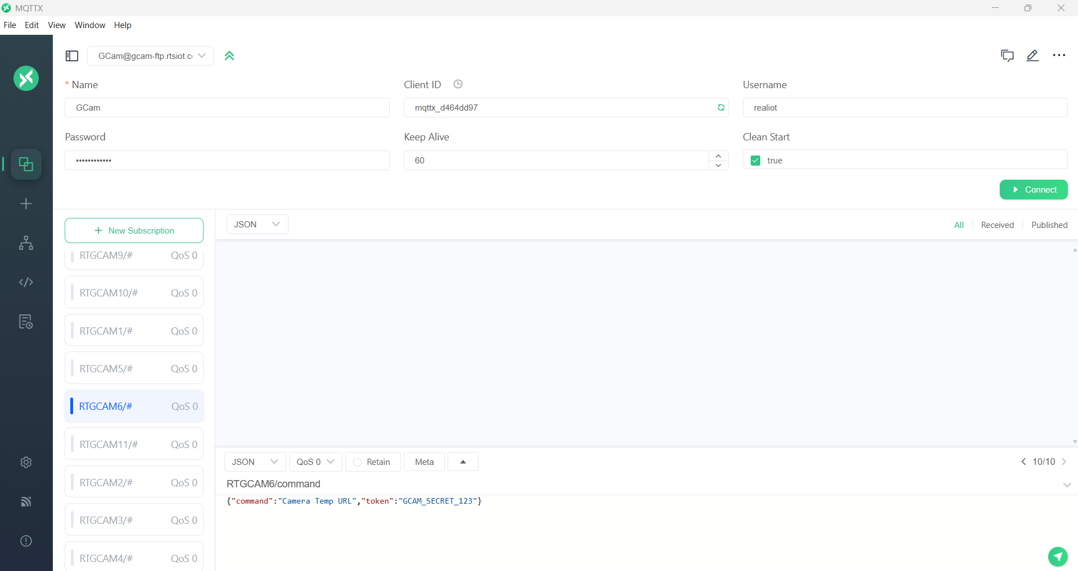
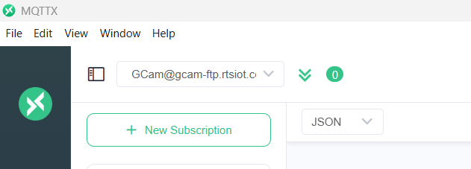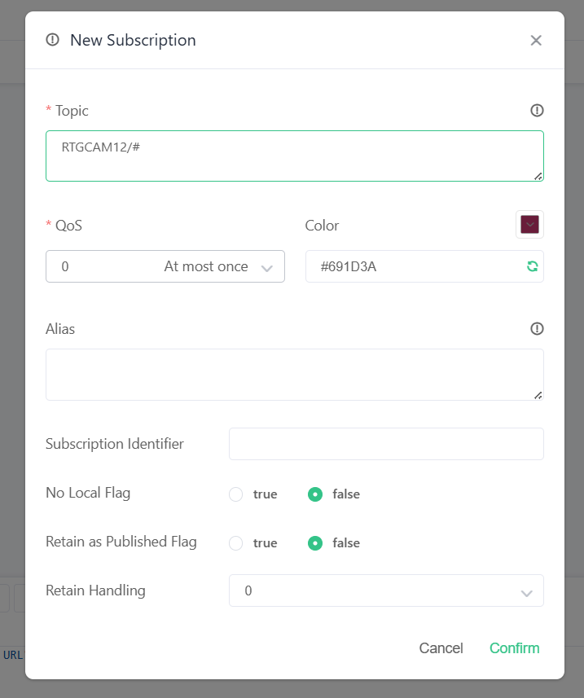
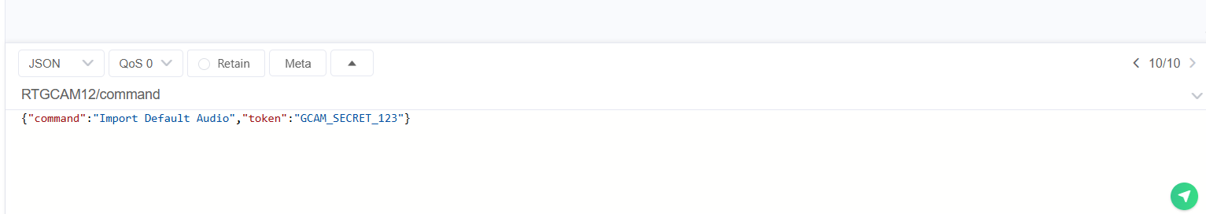
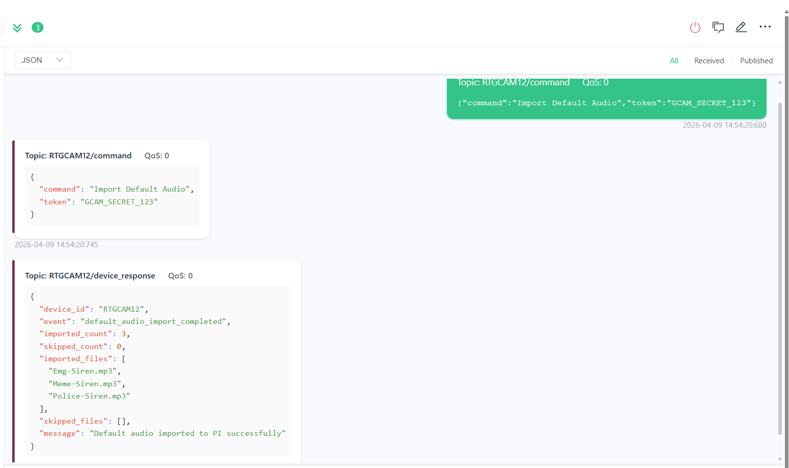

G-Cam MQTT:

For Live Stream Request:
{"command":"Live Stream","token":"GCAM_SECRET_123"}

For Manual Garbage Detection:
{"command":"Garbage Detect","token":"GCAM_SECRET_123"}

For Checking Device Status & Data:
{"command":"Data Status","token":"GCAM_SECRET_123"}

For Restart the Device:
{"command":"Device Restart","token":"GCAM_SECRET_123"}

For Audio Streaming (DVM-Direct Voice Message):
{"command":"Audio File Play","audio_name":"Store Ravi Announcement.mp3","token":"GCAM_SECRET_123"}
or
{"command":"Audio File Play","audio_path":"/home/ftpuser/ftp/files/Audio/Store Ravi Announcement.mp3","token":"GCAM_SECRET_123"}

For Close the G-Cam Software:
{"command":"Close The Software","token":"GCAM_SECRET_123"}

For Open the G-Cam Software:
{"command":"Open The Software","token":"GCAM_SECRET_123"}

For Restart the Device:
{"command":"Device Restart","token":"GCAM_SECRET_123"}

For Camera Setting Access:
{"command":"Camera Temp URL","token":"GCAM_SECRET_123"}

For Warning Audio Disable:
{"command":"Warning Audio Disable","token":"GCAM_SECRET_123"}

For Warning Audio Enable:
{"command":"Warning Audio Enable","token":"GCAM_SECRET_123"}

For Scheduled Warning Audio:
{"command":"Scheduled Warning Audio","start_time":"10AM","end_time":"6PM","token":"GCAM_SECRET_123"}

For Scheduled Warning Audio in 24hr Format:
{"command":"Scheduled Warning Audio","start_time":"10:00","end_time":"18:00","token":"GCAM_SECRET_123"}

For Disable Schedule Warning Audio:
{"command":"Scheduled Warning Disabled","token":"GCAM_SECRET_123"}

For Import Audio from Default Folder SFTP to PI:
{"command":"Import Default Audio","token":"GCAM_SECRET_123"}

For Erase the Audio from Default folder in PI:
{"command":"Erase Default Audio in PI","token":"GCAM_SECRET_123"}

For Play the Default Alert Audio:
{"command":"Play Default Audio - Meme-Siren.mp3","token":"GCAM_SECRET_123"}

For Set Garbage Detection on Schedule (Default 1Hour):
{"command":"Garbage Detection Set to 30mins","token":"GCAM_SECRET_123"}
or
{"command":"Garbage Detection Set to 3hours","token":"GCAM_SECRET_123"}

For Manual Reboot Router:
{"command":"Trigger Router Reboot","token":"GCAM_SECRET_123"}

